Project: Enhancing Wellbeing in Jordan
Client: Ministry of Health- Social Research and Planning

Team Members:
Hamzah Drawsheh & Tariq Al-Momani
Supervised By: Dr. Amera Al-Amery
# note: all this work done using Power BI
Technical View
- Abstract:
This technical report examines the relationships between food insecurity, psychological distress, resilience, and stress mindset among individuals in Jordan using data collected from over 900 participants. The analysis applies validated psychometric scales, including the Food Insecurity Experience Scale (FIES), the Kessler Psychological Distress Scale (K10), the Brief Resilience Scale (BRS), and the Stress Mindset Measure (SMM). Results indicate a strong negative association between resilience and psychological distress across all food security levels, suggesting that resilience functions as a protective factor even under conditions of food insecurity. Additionally, higher food insecurity is associated with increased psychological distress and lower resilience. Gender and age differences were observed, with younger participants and females reporting higher distress levels. Stress mindset showed a negative association with distress but did not significantly moderate the resilience–distress relationship.

- Introduction:
The Ministry of Health in Jordan aims to enhance subjective wellbeing by examining factors influencing mental health outcomes. Food insecurity, psychological distress, resilience, and stress-related beliefs are recognized as central determinants of wellbeing, particularly among young adults. This technical report presents an analysis of data collected through the Subjective Wellbeing Questionnaire (SWQ), which incorporates internationally validated scales. The objective of this report is to evaluate the relationships between food insecurity, psychological distress, resilience, and stress mindset, and to explore differences across gender and age groups. The findings provide empirical evidence to support policy development and targeted mental health interventions.
- Methodology
1- Data Preparation:
The dataset consisted of responses from 938 participants. Data cleaning procedures included removing duplicate records, excluding incomplete responses, renaming variables, data unification, data encoding, and standardizing response formats.

2- Scale Construction:
Food insecurity was assessed using the Food Insecurity Experience Scale (FIES), with responses recoded into binary values and aggregated into total and categorical indicators. Psychological distress was measured using the Kessler Psychological Distress Scale (K10), with item scores summed to create total distress scores and severity categories. Resilience was assessed using the Brief Resilience Scale (BRS), where negatively worded items were reverse-coded prior to calculating total scores. Stress mindset was measured using the Stress Mindset Measure (SMM), with reverse coding applied to negatively worded items before computing total scores.

3- Statistical Analysis:
Spearman’s rank correlation was used to assess associations between continuous variables due to non-normal distributions. Independent
t-tests were conducted to examine gender differences, while Kruskal–Wallis tests were applied to evaluate age group differences. Moderation analysis was performed using linear regression models.

- Results:
1- Resilience and Psychological Distress:
A significant negative association was observed between resilience and psychological distress across all levels of food security. This relationship remained consistent among individuals experiencing low food security, indicating that resilience functions as a protective factor regardless of food insecurity status.
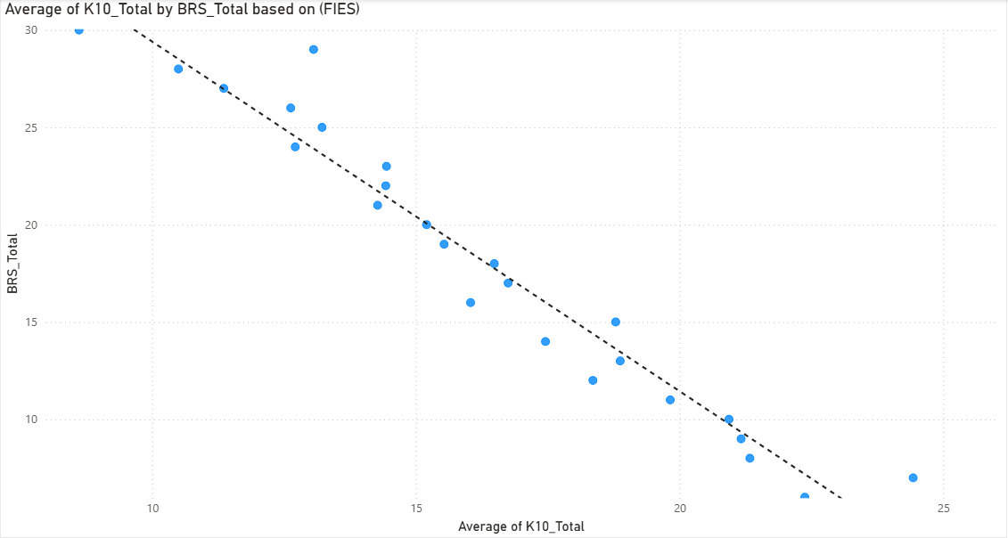

2- Food Insecurity and Mental Health:
Food insecurity was positively associated with psychological distress and negatively associated with resilience. Participants classified as having very low food security exhibited the highest levels of psychological distress.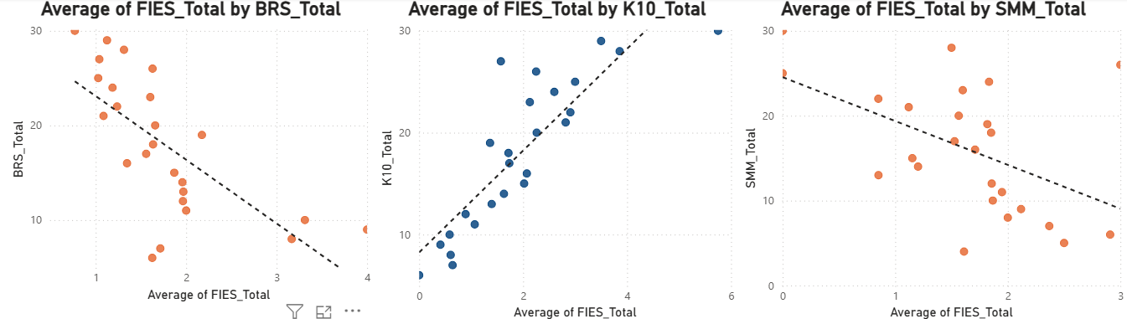

3- Demographic Differences:
Statistically significant differences were found by gender and age. Females and younger participants (18–22 years) reported higher psychological distress and lower resilience compared to males and older age groups.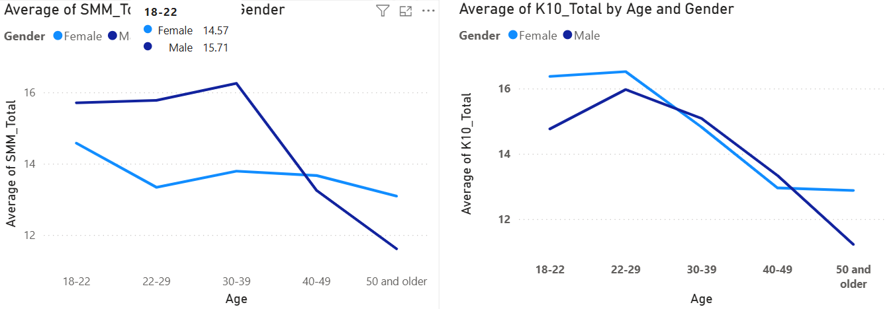

4- Stress Mindset:
Stress mindset was negatively associated with psychological distress. However, moderation analysis indicated that stress mindset did not significantly alter the relationship between resilience and psychological distress.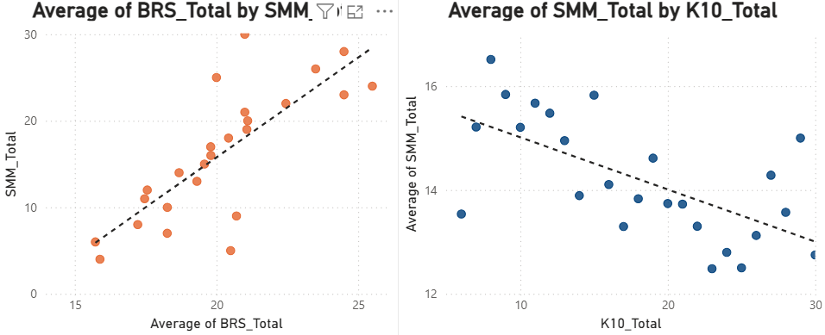

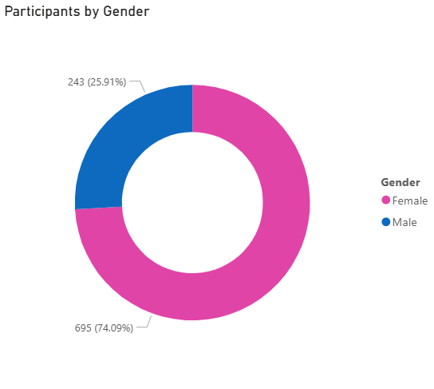
- Appendix:

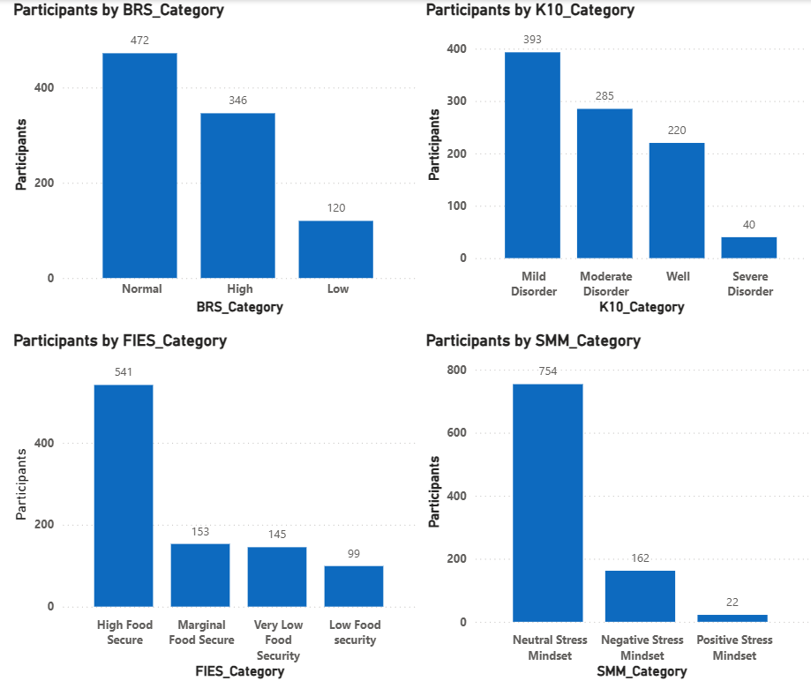
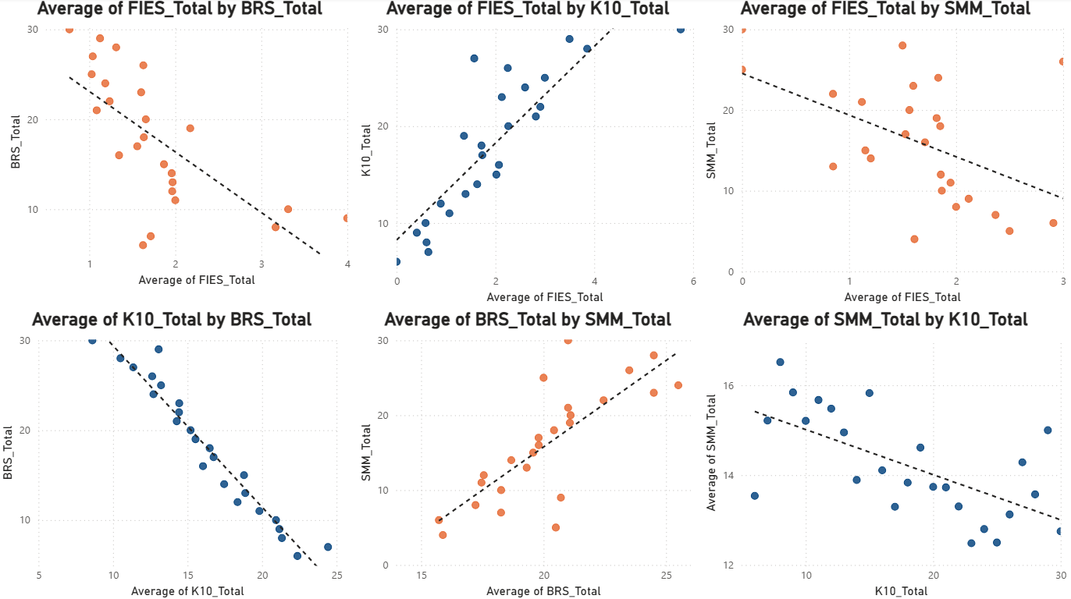

- These plots represent the central findings of the analysis. Higher scores on BRS and SMM and lower scores on K10 and FIES indicate positive outcomes, and the plots illustrate the associations among the four measures.

